**Homework 1 Introduction to Deep Learning.**

**Swapnil Kamate**

**Sk2181**

**Solution 1:**

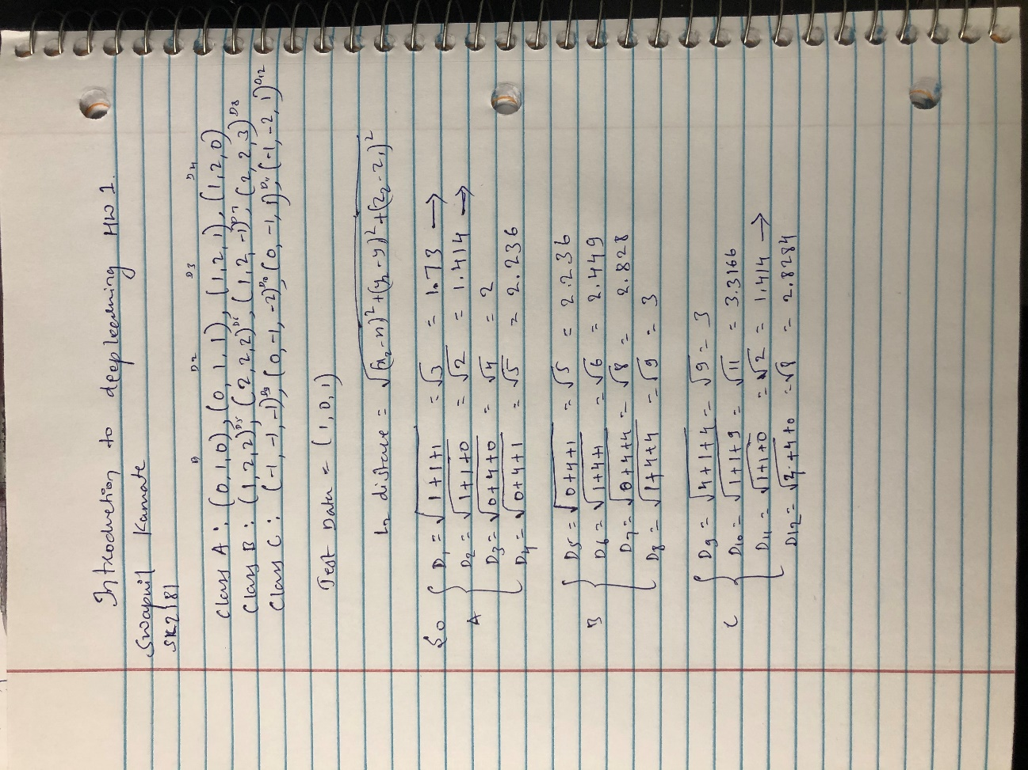

Result:

When K=1 We need to consider only one lowest distance. So, we could see the lowest distance(L2) is 1.414 which is both d2 and d11. So, when value of K =1 then our test data can fall into either Class A or Class C.

When K = 2 Again, in this case we need to consider two lowest distances which are again surprisingly 1.414 and 1.414 which are d2 and d11. So, when K = 2 our test data can fall into either Class A or Class C.

When K = 3, we need to consider 3 lowest distances and according to our results the three lowest distances are d2 = 1.414 -> Class A, d11 = 1.414 -> Class C and d1 = 1.73 -> Class A. We could see two of our distances fall in the Class A so, when K =3 I would say our test data can be classified as Class A result.

**Solution 2:**

**Source code:**

import numpy as np

import matplotlib as mpl

mpl.use('Agg')

import matplotlib.pyplot as plt

# load mini training data and labels

mini_train = np.load('knn_minitrain.npy')

mini_train_label = np.load('knn_minitrain_label.npy')

# randomly generate test data

mini_test = np.random.randint(20, size=20)

mini_test = mini_test.reshape(10,2)

# Define knn classifier

def kNNClassify(newInput, dataSet, labels, k):

result=[]

# compute L2 distance for all test and train samples

distances = []

for item1 in newInput:

d = []

for item2 in dataSet:

distance = np.sqrt(np.sum((item1-item2)**2)) #calclulating L2 distance

d.append(distance)

distances.append(d)

print(distances)

# decide which class the test samples belong in

for i in range(len(newInput)):

label_value = np.zeros(4) # creating an array for lable values

knn_indices = np.argsort(distances[i])[:k]

for j in range(len(knn_indices)):

label = labels[knn_indices[j]] #incrementing the count after getting each 'K'

label_value[label]+=1

result.append(np.argmax(label_value))

return result

outputlabels=kNNClassify(mini_test,mini_train,mini_train_label,4)

print ('random test points are:', mini_test)

print ('knn classfied labels for test:', outputlabels)

# plot train data and classfied test data

train_x = mini_train[:,0]

train_y = mini_train[:,1]

fig = plt.figure()

plt.scatter(train_x[np.where(mini_train_label==0)], train_y[np.where(mini_train_label==0)], color='red')

plt.scatter(train_x[np.where(mini_train_label==1)], train_y[np.where(mini_train_label==1)], color='blue')

plt.scatter(train_x[np.where(mini_train_label==2)], train_y[np.where(mini_train_label==2)], color='yellow')

plt.scatter(train_x[np.where(mini_train_label==3)], train_y[np.where(mini_train_label==3)], color='black')

test_x = mini_test[:,0]

test_y = mini_test[:,1]

outputlabels = np.array(outputlabels)

plt.scatter(test_x[np.where(outputlabels==0)], test_y[np.where(outputlabels==0)], marker='^', color='red')

plt.scatter(test_x[np.where(outputlabels==1)], test_y[np.where(outputlabels==1)], marker='^', color='blue')

plt.scatter(test_x[np.where(outputlabels==2)], test_y[np.where(outputlabels==2)], marker='^', color='yellow')

plt.scatter(test_x[np.where(outputlabels==3)], test_y[np.where(outputlabels==3)], marker='^', color='black')

#save diagram as png file

plt.savefig("miniknn.png")

**Screenshot of code:**

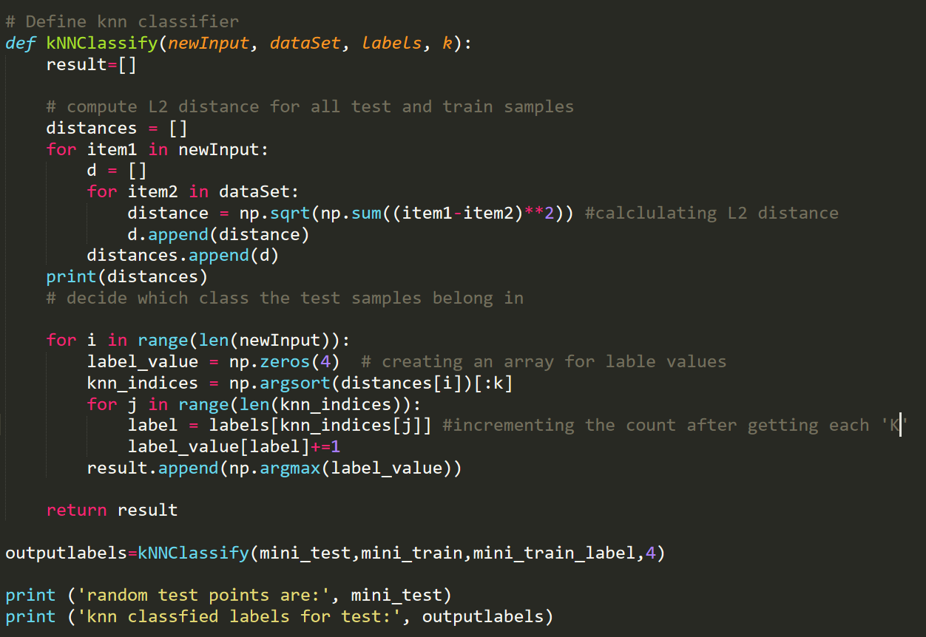

**Output of plotted Image**

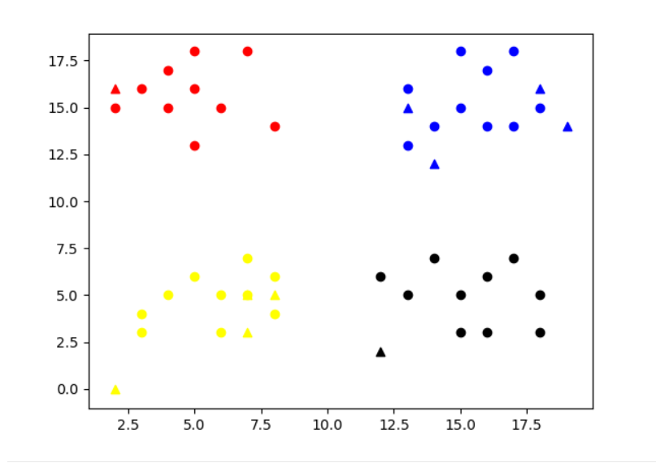

**CMD Output:**

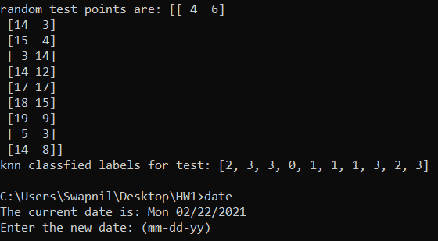

**Solution 3:**

**Source Code:**

import math

import numpy as np

from download_mnist import load

import operator

import time

# classify using kNN

#x_train = np.load('../x_train.npy')

#y_train = np.load('../y_train.npy')

#x_test = np.load('../x_test.npy')

#y_test = np.load('../y_test.npy')

x_train, y_train, x_test, y_test = load()

x_train = x_train.reshape(60000,28,28)

x_test = x_test.reshape(10000,28,28)

x_train = x_train.astype(float)

x_test = x_test.astype(float)

def kNNClassify(newInput, dataSet, labels, k):

result=[]

# compute L2 distance for all test and train samples

distances = np.zeros((len(newInput), len(dataSet)))

for i in range(len(newInput)):

for j in range(len(dataSet)):

distance = np.sqrt(np.sum((newInput[i]-dataSet[j])**2))

distances[i, j] = distance

# decide which class the test samples belong in

for i in range(len(newInput)):

label_value = np.zeros(10)

knn_indices = np.argsort(distances[i])[:k]

for j in range(len(knn_indices)):

label = labels[knn_indices[j]]

label_value[label]+=1

result.append(np.argmax(label_value))

return result

start_time = time.time()

outputlabels=kNNClassify(x_test[0:20],x_train,y_train,10)

result = y_test[0:20] - outputlabels

result = (1 - np.count_nonzero(result)/len(outputlabels))

print ("---classification accuracy for knn on mnist: %s ---" %result)

print ("---execution time: %s seconds ---" % (time.time() - start_time))

**Screenshot of Code:**

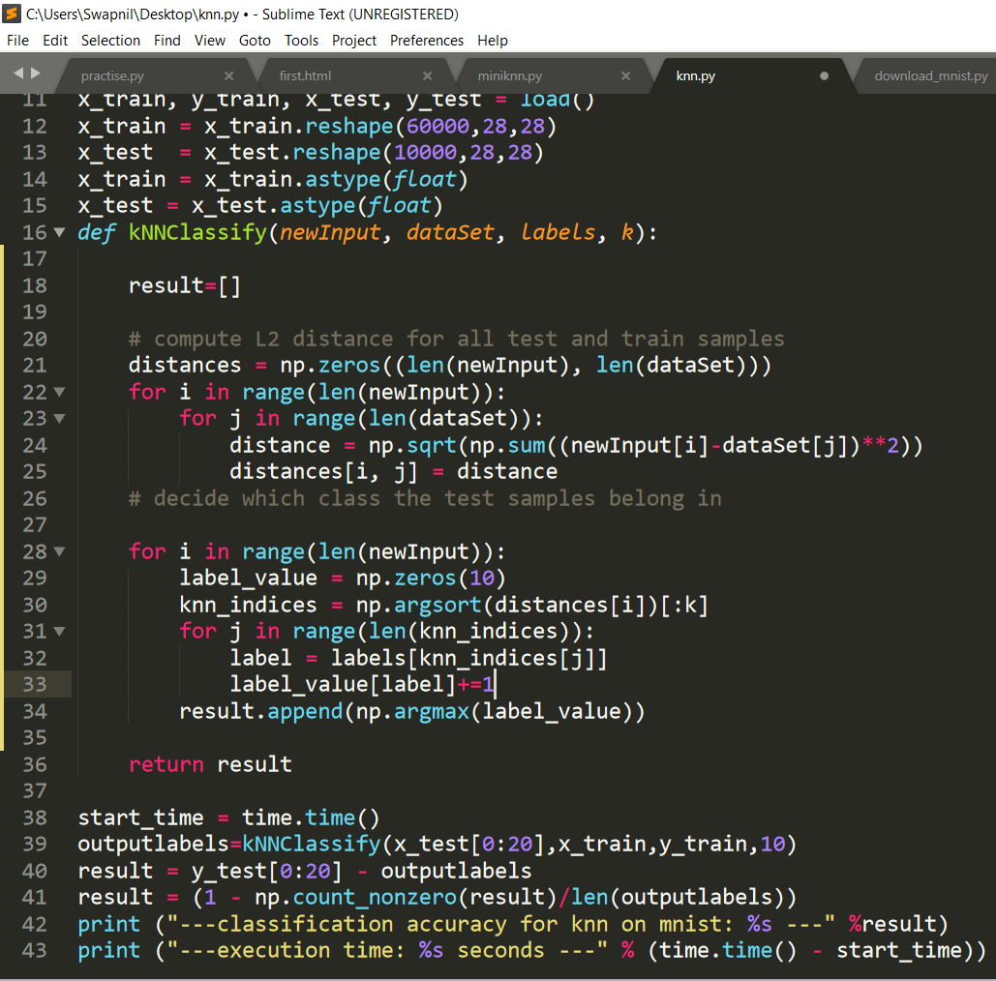

**Output:**

